**Lab Exercise 6**

In this lab exercise, you’ll practice reading from text files and perform preliminary text analysis.

You can use the following partial code as the basis for this exercise.

|  |
| --- |
| input_file=open(*"Lord_of_the_rings.txt"*,*"r"*)  output_file=open(*"Word_list.txt"*,*"w"*)  line_counter=0  word_counter=0  word_dict={}  for line in input_file:  line_counter+=1  words=line.split()  for word in words:  word_counter+=1  if word not in word_dict:  word_dict[word]=1  print(word,file=output_file)  else:  word_dict[word]+=1  print(*"The total number of words is approximately "*,word_counter)  print(*"The total number of liens is approximately "*,line_counter)  print(*"The total number of different words is approximately "*,len(word_dict))  input_file.close()  output_file.close() |

The program above reads from a text file, and count the number of lines, words, and unique words. Additionally, it save all the unique words in an output file named Word_list.txt.

**Task 1**

1. Extend the program so that it also counts
   1. the number of blank lines
   2. the number of words starting with “pre”
   3. the number of words ending with “ing”

Sample output:

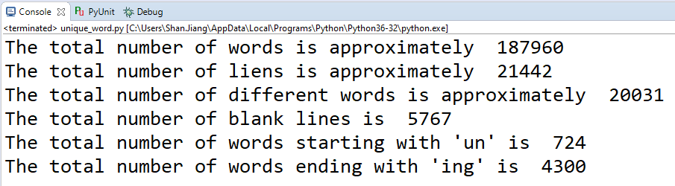

**Sample Answer:**

|  |
| --- |
| input_file=open(*"Lord_of_the_rings.txt"*,*"r"*)  output_file=open(*"Word_list.txt"*,*"w"*)  line_counter=0  blank_line_counter=0  word_counter=0  un_counter=0  ing_counter=0  word_dict={}  for line in input_file:  line_counter+=1  words=line.split()  if len(words)==0:  blank_line_counter+=1  for word in words:  word_counter+=1  if word[:2]==*"un"*:  un_counter+=1  if word[-3:]==*"ing"*:  ing_counter+=1  if word not in word_dict:  word_dict[word]=1  print(word,file=output_file)  else:  word_dict[word]+=1  #@Author: Shan.Jiang  print(*"The total number of words is approximately "*,word_counter)  print(*"The total number of liens is approximately "*,line_counter)  print(*"The total number of different words is approximately "*,len(word_dict))  print(*"The total number of blank lines is "*,blank_line_counter)  print(*"The total number of words starting with 'un' is "*,un_counter)  print(*"The total number of words ending with 'ing' is "*,ing_counter)  input_file.close()  output_file.close() |

**Task 2**

1. Extend the program so that it saves all the unique words ending with “ing” in an output file named ing_word_list.txt.

Sample output:

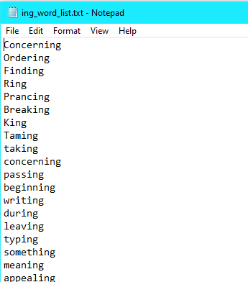

**Sample Answer:**

|  |
| --- |
| input_file=open(*"Lord_of_the_rings.txt"*,*"r"*)  output_file=open(*"Word_list.txt"*,*"w"*)  ing_output_file=open(*"ing_word_list.txt"*,*"w"*)  line_counter=0  blank_line_counter=0  word_counter=0  un_counter=0  ing_counter=0  word_dict={}  for line in input_file:  line_counter+=1  words=line.split()  if len(words)==0:  blank_line_counter+=1  for word in words:  word_counter+=1  if word[:2]==*"un"*:  un_counter+=1  if word[-3:]==*"ing"*:  ing_counter+=1  if word not in word_dict:  word_dict[word]=1  print(word,file=output_file)  else:  word_dict[word]+=1  #@Author: Shan.Jiang  print(*"The total number of words is approximately "*,word_counter)  print(*"The total number of liens is approximately "*,line_counter)  print(*"The total number of different words is approximately "*,len(word_dict))  print(*"The total number of blank lines is "*,blank_line_counter)  print(*"The total number of words starting with 'un' is "*,un_counter)  print(*"The total number of words ending with 'ing' is "*,ing_counter)  for word in word_dict:  if word[-3:]==*"ing"*:  print(word,file=ing_output_file)    input_file.close()  output_file.close()  ing_output_file.close() |

**Requirements:**

1. Save your code after Task 2. Name the code file as yourname_lab6.py*.*
2. Upload the .py file to Blackboard. You don’t need to upload the ing_word_list.txt*.*

*Note that the grading is effort-based. You can get 3 points for this exercise, as long as you submit your code that did NOT copy the sample answer(s).*